DevOps Assignment Submission Template

1. Student Details
Field | Information
Name | Hemakshi Gohil
Email | honeygohil95@gmail.com
College/Institute | Anand Institute of Management and Information Science
Date of Submission | 29/09/2025

2. Assignment Details
Field | Information
Assignment Title | DevOps Practical Assignment
Repository Name | https://github.com/Honey-gohil/devops-assignment.git
Feature Branch Name | feature/Honey-gohil-hello-route

3. Deliverables
Deliverable | Details / Links / Screenshots
GitHub Repository URL | https://github.com/Honey-gohil/devops-assignment.git
Pull Request Link (Attach Screenshot Below) | 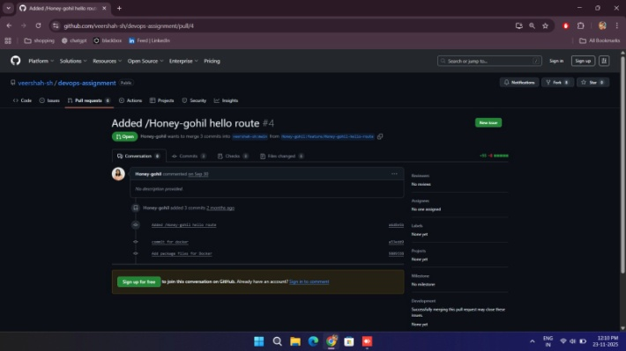
Docker Build Proof (Screenshot) | 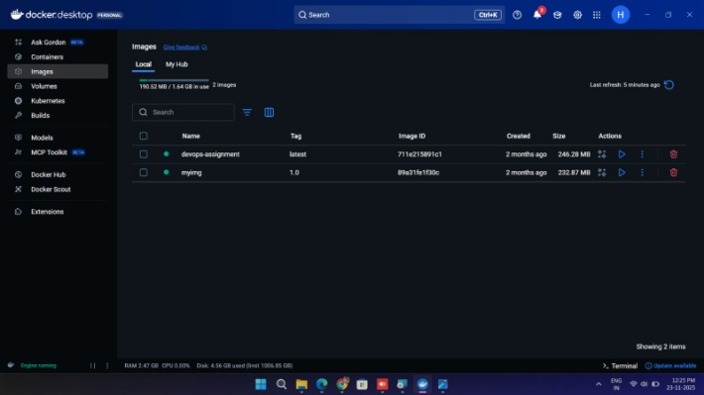
Jenkins Pipeline Proof (Screenshot) | [For Some reason it doesn’t works.]  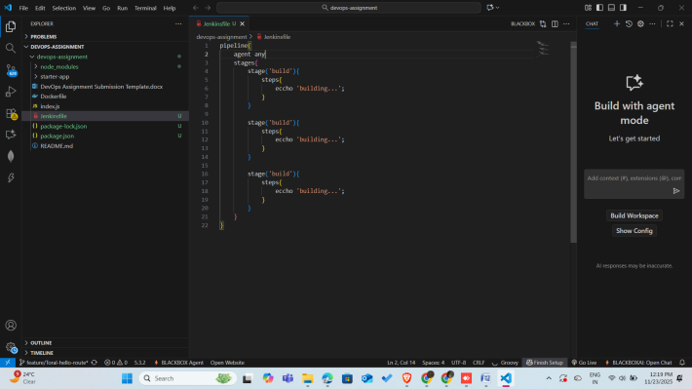
Deployment Proof (Browser Screenshot) | 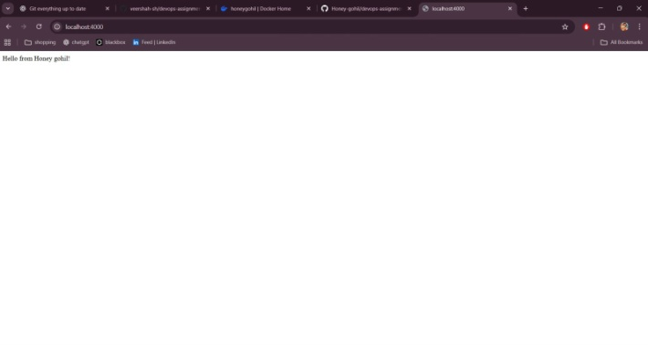

4. Notes
Everything was clear and well-directed. I gained a lot of knowledge, particularly regarding pipelines and automation. The only issue was a Jenkins error that would not go away. However, I learned more from it than it hindered me.

